Local Authority

Challenge: Local Authority
Category: Web Exploitation
Difficulty: Easy

Access the Website
I accessed the provided URL:
http://saturn.picoctf.net:54959/

Attempt to Login
I tried logging in with random credentials:
- Username: asdasdw
- Password: sdawgads

The login returned:
Log In Failed
Then I pressed ctrl+U
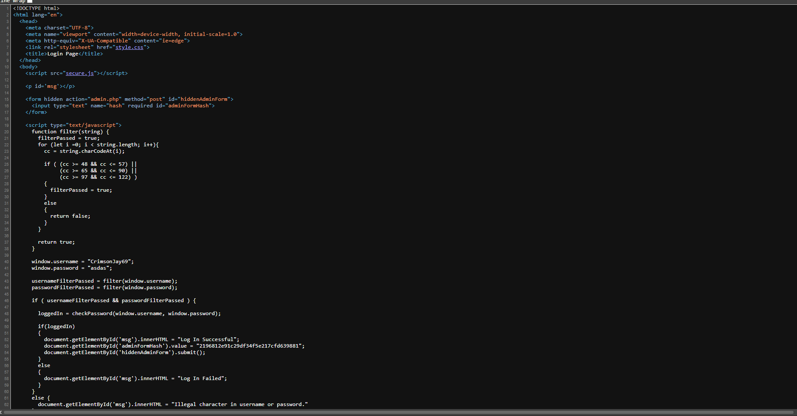

Then I lciked secure.js

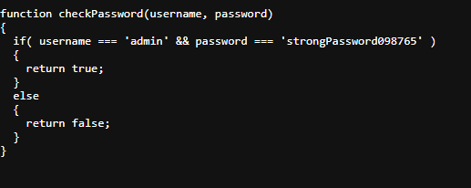

FLAG: picoCTF{j5_15_7r4n5p4r3n7_05df90c8}

